To my project implementation, I have taken the microservice architectural approach, I will use Docker as the support platform. I will use vs code as my IDE and git and GitHub for version control. The following diagram outlines the system architecture and the technology used:

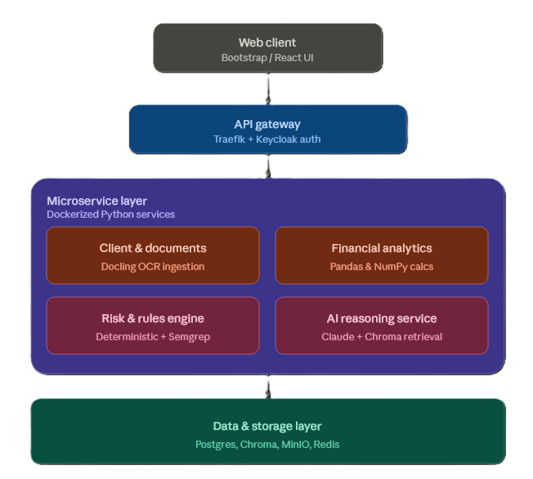
I understand that according to the sources and the files I provided, you have by now know and understand my system scope, functional requirements, workflow, roles and more importantly the system features and project management approach.

You will be my project companion, assistant, guide and help to ensure we achieve the project objectives.
What you need to do now for the project implementation are:
- Provide a structural plan, plan and outline several project implementation phases. From tools and environment setup all the way to testing and deployment. This essential because it is easy to maintain, know the progress and what to do next.

